TITLE OF YOUR PAPER (TNR, Bold 14pt centered)

Author, A¹, Author, B², and Author, C³ (TNR 12pt centered)

¹Institution 1(TNR 12pt centered)
²Institution 2 (TNR 12pt centered)
³Institution 3 (TNR 12pt centered)
E-mail (corresponding author)

Abstract (headlines: TNR Bold, 12pt, Italic)
The working committee cordially invite all researchers, academicians, industry and other players in halal domain or business to submit papers which deemed relevant to the topics and themes highlighted in the International Halal Conference on Research and Technical 2020 (IHCReT2020). All accepted papers will be published in various SCOPUS indexed journals accordingly to the discipline and the journal theme. In order to get published in these indexed journals, the author/s need to ensure the quality of own paper that to be submitted to IHCReT2020. Abstract section should not exceed 200 words.

Keywords: please list two, three, or maximum four keywords, separated by comma

- INTRODUCTION (headlines: TNR Bold, 12pt)
In conjunction with the IHCReT2020 theme, papers of relevant topics within the conference theme are invited for oral presentations. Authors are requested to submit a paper between six (6) to eight (8) pages, written in English language.
The paper must include a title, author(s), introduction, material and methods, results and discussion, conclusion and references. For papers from industry or non-academics, the paper should include descriptions of the products or services, innovations, applications, results, discussion, benefits to users, conclusion and references. The manuscript should be prepared on an A4-sized paper with 25 mm margins on all sides and typed with single spacing using size 12 Times New Roman font. All illustrations must be prepared inside of the main text. Selected papers will be published in specified Scopus cited journals (as will be advised after IHCReT2020 conference day). Extra pages will be charged separately.

- MATERIALS AND METHODS (headlines: TNR, Bold, 12pt)

The methodology must be clearly stated and described in sufficient detail or with sufficient references.

- RESULTS AND DISCUSSION (headlines: TNR Bold, 12pt)
The findings and arguments of the work should be explicitly described and illustrated. Supporting figures, tables and images of the work ought to be included.
All the tables, images and figures should be centered. Figures and images should be numbered and figure headers should be placed under the figure or image; as for the tables, they should also be numbered and the table header should be placed at the top. References (if any) of the tables, figures and images should be presented right under the tables, figures and images in the form of author surname and publication date.

- USING THE TEMPLATE FOR SEVERAL COMPONENTS (headlines: TNR Bold, 12pt)

4.1 Equations
Equations should be centered and numbered consecutively, as in Eq. [1]. An alternative method is given in Eq. [2] for long sets of equations where only one referencing equation number is wanted.
(1 line spacing here)

 |  | [1]
where, | (1 line spacing here)
 |  | [2]

  - List
Lists can be provided using either numbers or bullets:
- List item 1 like this;
- List item 2 is an example of a longer list item that wraps to a second line, where the second line is indented.
The example for bulleted items like this:
- List item 1;
- List item 2.

  - Tables and figures
Tables and figures should appear in one column of a page and be numbered consecutively. Figures and texts may appear on the same page, and a centered caption should appear directly beneath the figure. It is preferable that figures be mounted in portrait style and figure captions are no longer than two lines. On figures showing graphs, both axes must be clearly labeled (including units if applicable).
Tables should be designed to have a uniform style throughout the paper, following the style shown in Table 1. Table captions should be in 10pt “Time News Roman” bold, centered, and the texts in Table should be set in 9pt “Time News Roman” font.

Table 1. Caption heading for a table should be placed at the top of the table and within table width.
(Use “time news roman” font, size 10pt, No spacing after table title)
 | A | B | C | D
A | Aa | Ab | Ac | Ad
B | Ba | Bb | Bc | Bd
C | Ca | Cb | Cc | Cd
D | Da | Db | Dc | Dd
E | Ea | Eb | Ec | Ed

Authors are advised to prepare their figures in either black and white or color. Please prepare the figures in high resolution (300 dpi) for half-tone illustrations or images. Pictures must be sharp enough otherwise they will be rejected. Figures must be originals, computer-generated or drafted, and placed within the text area where they are discussed. Figure 1 shows one example. Figure captions should be in 10pt “Time News Roman” font, bold, centered. When applicable, the texts in graphs, illustrations or images should be set in 8pt “Time News Roman” font.
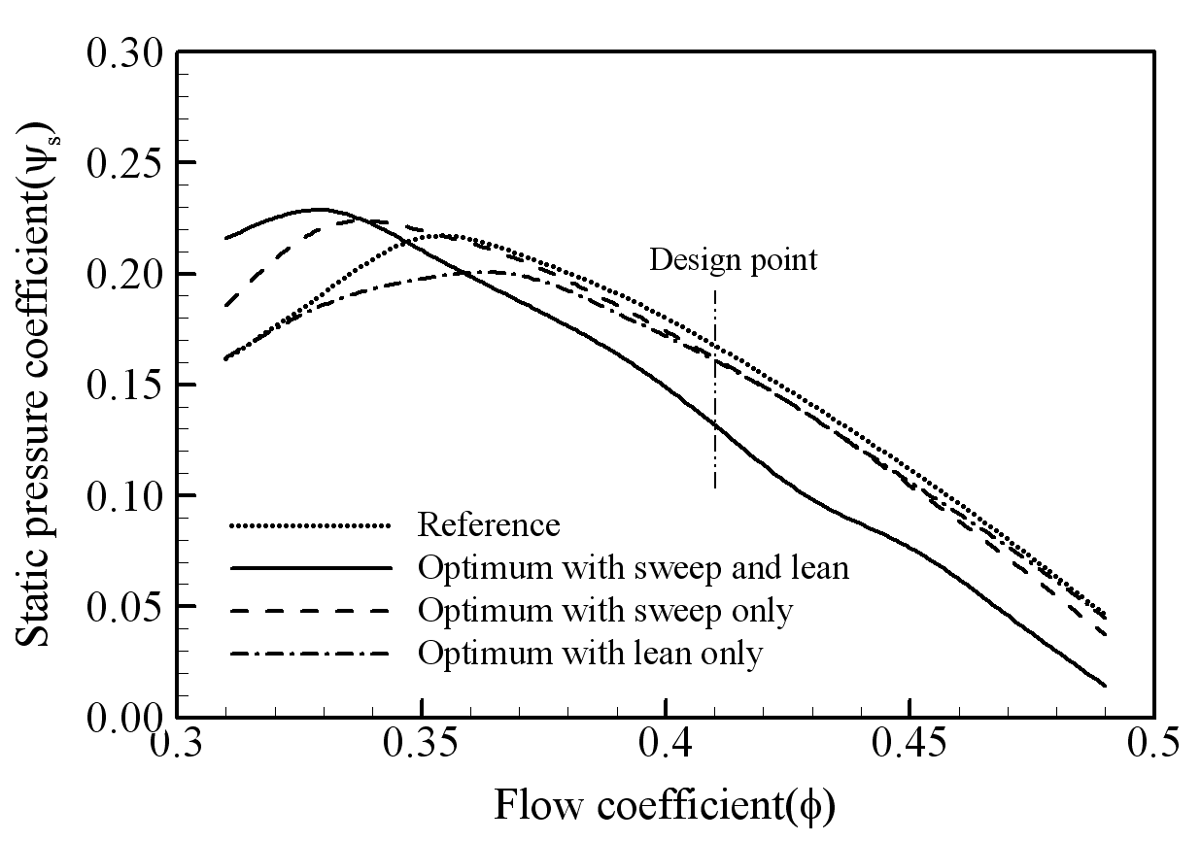
Figure 1. The caption heading for a figure should be placed below the figure and within figure/illustration width. (Use “Time News Roman” font, size 10pt, no spacing between title and figure)

  - Footnotes
Footnotes are denoted by a character superscript in the text b.

  - Units
Use either SI (MKS) as primary units. English or CGS units may be used as secondary units (in parentheses). Avoid combining SI and CGS units. This often leads to confusion because equations do not balance dimensionally. If you must use mixed units, clearly state the units for each quantity that you use in an equation. Do not mix complete spellings and abbreviations of units. Spell out units when they appear in text.

- CONCLUSION (headlines: TNR Bold, 12pt)
Conclusions should include (1) the principles and generalisations inferred from the results, (2) any exceptions to, or problems with these principles and generalisations, (3) theoretical and/or practical implications of the work, and (5) conclusions drawn and recommendations.

- ACKNOWLEDGMENT (headlines: TNR Bold, 12pt)
The authors would like to express appreciation for the support of the sponsors [Project Number = XXXXXXX].

- REFERENCES (headlines: TNR Bold, 12pt)
References should be listed arranged in alphabetical order beginning with the author’s names and initials, followed by the year of publication, title of periodical, volume and page. Example:
Parlange, J.Y., R. Haverkamp and J. Touma. 1985. Infiltration under ponded condition: 1. Optimal analytical solution and comparison with experimental observation. Soil Sci., 139: 305-311.
In the text, references should be cited with the name of the author(s) with the year of publication in parenthesis, e.g., Philip (1957), Taylor and Baker (1986), Smith et al. (1987).

b Just like this one.

